EXPERIMENT 3: LINEAR REGRESSION
Aim: To implement a Linear Regression model to predict students' marks based on the number of hours studied.
ALGORITHM:
- Import Pandas, Matplotlib, and the required Scikit-learn modules.
- Load the dataset from data.csv.
- Select Hours_Studied as the input feature and Marks as the target variable.
- Split the dataset into training and testing sets in an 80:20 ratio.
- Create a Linear Regression model.
- Train the model using the training data.
- Predict the marks for the testing data.
- Evaluate the model using Mean Squared Error (MSE) and the R2 score.
- Display the predicted marks.
- Plot the actual data points and the regression line.

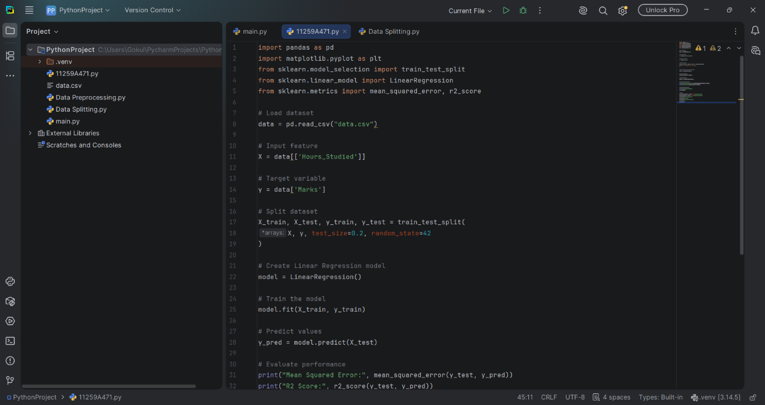

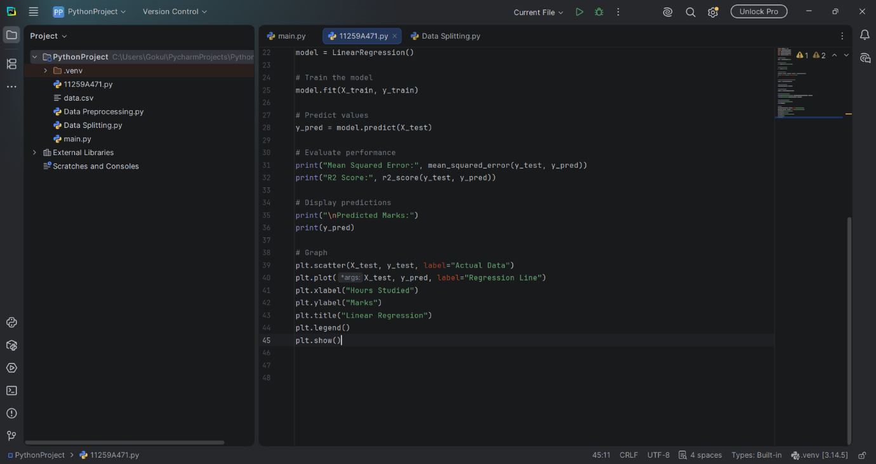
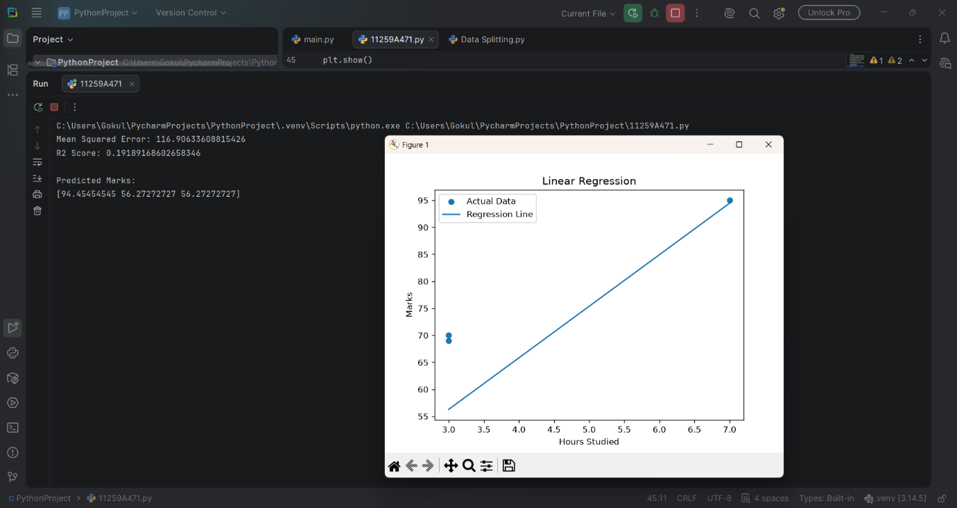

RESULT:
The Linear Regression model was successfully trained to predict marks based on study hours. Its performance was evaluated using MSE and the R2 score, and a graph was generated to visualize the predictions.

